# **HTML PROJECT**

“KASADE OIL & GAS”

PRESENTED BY

Ojo Taye John, Safiyya Bayero

and

Kassim Abdullateef

**A PROJECT SUBMITTED IN PARTIAL FULFILLMENT FOR THE REQUIREMENTS FOR THE COMPLETION OF HTML PROGRAMMING.**

OCTOBER 2023

**NIIT**

# **DECLARATION**

The project members; OJO JOHN, SAFIYYA BAYERO and ABDULLATEEF KASSIM, hereby declare that this project “**KASADE”** has been carried out by the names mentioned above, under the supervision of “**MR NASHIA MAMMAN**”. It has not been presented for award of any degree in the institute. All sources of information are specifically recognized by means of reference.

# **APPROVAL**

The project titled “KASADE” by: **OJO JOHN, SAFIYYA BAYERO, and ABDULLATEEF KASSIM**, meets the requirement overseeing the completion of the course ***HTML PROGRAMMING*** and is approved for its contribution to knowledge and literacy presentation.

**________________ ________________**

**Mr. NASHIA MAMMAN Date**

**(Project supervisor)**

**________________ ________________**

**Mrs. Lilian. Nnadri Date**

**(Centre head)**

# **DEDICATION**

We dedicate this project to the Almighty God, our families for their endless support towards the completion of this project, our supervisor for his guidance during the course of this project and to the staff of NIIT for providing an enabling environment for our study.

# **ACKNOWLEDGEMENT**

We would like to use this section to express our in-depth gratitude to quite a number of persons who inspired, encouraged, guided and supported us on the journey towards the actualization of this project.

# **ABSTRACT**

KASADE Oil and Gas Company is a prominent player in the global energy sector, specializing in the exploration, production, and distribution of petroleum and natural gas resources. With a strong commitment to sustainable practices and cutting-edge technology, the company has established itself as a leader in the industry.

**Key Highlights:**

**Diverse Portfolio:** Kasade Oil and Gas Company maintains a diverse portfolio of oil and gas assets, both onshore and offshore, in multiple regions around the world. This diversity helps to mitigate risk and ensures a stable supply of energy resources.

**Advanced Technology:** We leverages state-of-the-art technology for exploration and production, including 3D seismic imaging, drilling automation, and data analytics, which enables efficient and environmentally responsible operations.

**Global Presence:** With a global reach, we company operates in numerous countries, forming partnerships and joint ventures with local and international entities to strengthen its market position and foster innovation.

*.*

# ­­­­­­­TABLE OF CONTENT

Contents

**HTML PROJECT** 1

**DECLARATION** 2

**APPROVAL** 3

**DEDICATION** 4

**ACKNOWLEDGEMENT** 5

**ABSTRACT** 6

TABLE OF CONTENT 7

**CHAPTER ONE** 9

INTRODUCTION 9

1.1 BACKGROUND OF STUDY 9

1.2 STATEMENT 10

1.3 AIMS AND OBJECTIVE 10

1.4 SIGNIFICANCE OF STUDY 11

1.5 SCOPE AND LIMITATION 11

**CHAPTER TWO** 12

LITERATURE REVIEW 12

2.2 HISTORY OF HTML 12

2.3 HTML WORKING ENVIRONMENT 13

**CHAPTER THREE** 15

METHODOLOGY & DESIGN 15

3.1 REQUIREMENTS 15

3.2 DESGIN / DESCRIPTION 15

**CHAPTER FOUR** 18

SUMMARY, CONCLUSION AND RECOMMENDATION 18

4.1 SUMMARY 18

4.2 CONCLUSION 18

4.3 RECOMMENDATION 18

**REFRENCES** 19

References 19

# **CHAPTER ONE**

## INTRODUCTION

In this chapter, we shall be talking about the application used to produce this project i.e. Visiual Studio Code, Its Aims and Objectives, Significance of the Study and Scope and Limitations of the project.

### BACKGROUND OF STUDY

**The Need for a Lightweight Code Editor:**

Prior to the development of Visual Studio Code, Microsoft had its Visual Studio IDE, which was a comprehensive and feature-rich integrated development environment. However, there was a growing need for a lightweight, fast, and highly customizable code editor that could be used for a wide range of programming languages and tasks.

**Emergence of Open Source and Cross-Platform Development:**

The software development landscape was evolving, with open-source technologies becoming increasingly popular, and developers working on various platforms, including Windows, macOS, and Linux. Microsoft recognized the importance of catering to this diverse developer ecosystem.

**Popularity of Web Technologies:**

Web development and web technologies were on the rise. A lightweight code editor that could seamlessly integrate with web technologies like JavaScript, HTML, CSS, and various web frameworks was in demand.

**The Rise of Visual Studio Code:**

In 2015, Microsoft introduced Visual Studio Code, which was designed to address these evolving needs. VS Code was built on Electron, a framework for building cross-platform desktop applications using web technologies. This allowed it to run on Windows, macOS, and Linux.

**Key Features and Design Philosophy:**

VS Code was designed with the following principles in mind:

Productivity: It aimed to boost developers' productivity through a highly efficient code editing experience.

**Customizability:** Developers could customize and extend VS Code with a wide range of extensions and themes.

**Evolution and Ecosystem Building:**

Over the years, VS Code has evolved with regular updates, new features, and an extensive marketplace of extensions. It has become a preferred choice for many developers across different domains.

**Language Support:** VS Code provided support for numerous programming languages and integrated tools for debugging and version control.

### STATEMENT

At Kasade, we are dedicated to powering the world's energy needs while embracing sustainable and responsible practices. Our commitment to excellence, innovation, and environmental stewardship is at the core of everything we do.

**Our Mission:** To be a global leader in the exploration, production, and distribution of energy resources, providing reliable and affordable energy solutions to meet the demands of today and tomorrow.

Our Values:

Safety First: We prioritize the safety and well-being of our employees, partners, and the communities where we operate. Our goal is to achieve zero harm and promote a safety culture in all aspects of our business.

Environmental Responsibility: We are dedicated to minimizing our environmental footprint. We invest in cutting-edge technologies and practices to reduce emissions, protect ecosystems, and promote energy efficiency.

### AIMS AND OBJECTIVE

**Transparency and Accountability:** To promote transparency and accountability by providing financial reports, sustainability reports, and updates on safety and environmental practices to investors and regulatory bodies.

### SIGNIFICANCE OF STUDY

**Information Dissemination:** Oil and gas websites are primary sources of information regarding a company's operations, projects, and industry trends. Studying these websites provides valuable insights into the current state of the industry, technological advancements, and the strategies and activities of oil and gas companies.

**Transparency and Accountability:** Many oil and gas companies use their websites to provide financial reports, sustainability reports, safety records, and environmental practices. This transparency enhances accountability, allowing stakeholders to assess a company's performance in areas like environmental responsibility and safety.

**Investor Relations:** For investors and potential investors, oil and gas websites are crucial sources of information. Studying these websites helps investors make informed decisions about investment opportunities, financial stability, and long-term prospects of oil and gas companies.

**SCOPE AND LIMITATION**

**Security and Sensitive Information:** Security concerns limit the extent of information that can be shared on an oil and gas website. Companies may need to restrict access to sensitive data, especially regarding infrastructure and proprietary technologies.

**Regulatory Compliance:** Oil and gas websites must adhere to various industry regulations, including those related to data privacy, environmental reporting, and financial disclosures. These regulations can limit the scope of certain information.

**Community Expectations:** Websites must balance community engagement with community expectations. Sensitive community issues may need to be handled offline to maintain positive relations.

# **CHAPTER TWO**

## LITERATURE REVIEW

Literature review defines Vs Code and gives a historical background to the creation of Vs Code

**2.1 DEFINITION OF Vs Code**

Visual Studio Code (VS Code) is a free, open-source source code editor developed by Microsoft. It is a highly popular and versatile code editor that is widely used by developers for various programming languages and development tasks. VS Code is known for its lightweight and fast performance, a vast ecosystem of extensions, and extensive customization options. It is available on multiple platforms, including Windows, macOS, and Linux, making it a valuable tool for software development, coding, and scripting across a wide range of domains and programming languages.

### 2.2 HISTORY OF Vs Code

Visual Studio Code (VS Code) is a relatively new but rapidly growing code editor developed by Microsoft. Here is a brief history of VS Code:

April 29, 2015: Microsoft officially announced Visual Studio Code. It was introduced as a free, open-source code editor that aimed to provide a lightweight and highly customizable development environment.

Launch and Early Releases: The initial release of VS Code was based on Electron, a framework for building cross-platform desktop applications using web technologies. It was available for Windows, macOS, and Linux, making it accessible to a broad range of developers.

Key Features: From the beginning, VS Code offered a range of essential features, including intelligent code completion, syntax highlighting, debugging capabilities, and Git integration. These features made it appealing to a wide audience of developers.

**2.3 Vs Code WORKING ENVIRONMENT**

Visual Studio Code (VS Code) provides a flexible and highly customizable working environment for developers. Here are the key components of the VS Code working environment:

Editor: The central part of the VS Code interface is the code editor itself. It is where you write, edit, and view your source code and other text-based files. The editor is equipped with features like syntax highlighting, auto-indentation, and code completion.

File Explorer: On the left-hand side of the interface, you have the file explorer, which allows you to browse your project's files and directories. You can open, create, and manage files and folders directly from this panel.

Integrated Terminal: VS Code includes an integrated terminal that lets you run command-line tools and scripts without leaving the editor. You can access the terminal at the bottom of the interface.

# **CHAPTER THREE**

## METHODOLOGY & DESIGN

The aim of this chapter is to give a guide through of how the Website with the name “**KASADE**” was designed from the beginning to the end.

### 3.1 REQUIREMENTS

The following materials were used from inception to the end.

1. Visual Studio Code

2. Microsoft word.

3. PowerPoint.

4. Bootstrap

5. Github

### 3.2 DESGIN / DESCRIPTION

KASADE Oil and Gas Company is a prominent player in the global energy sector, specializing in the exploration, production, and distribution of petroleum and natural gas resources. With a strong commitment to sustainable practices and cutting-edge technology, the company has established itself as a leader in the industry.

Design Elements:

**Homepage:**

Clean and welcoming design with an image of a sustainable home.

Clear navigation menu for easy access to different sections.

A prominent call-to-action (CTA) encouraging visitors to explore our services.

**About Us:**

An "About Us" section introducing the company's mission, values, and commitment to eco-friendly practices.

Profiles of key team members to establish trust and credibility.

Services:

Detailed descriptions of our eco-friendly services, including solar panel installation, energy-efficient windows, and sustainable roofing.

High-quality images and infographics illustrating the benefits of each service.

Regularly updated blog with articles on green living, energy-saving tips, and eco-friendly home improvement trends.

**Contact Us:**

Contact form for inquiries and requests for quotes.

Phone number, email address, and a physical address for contacting us directly.

A map with the company's location.

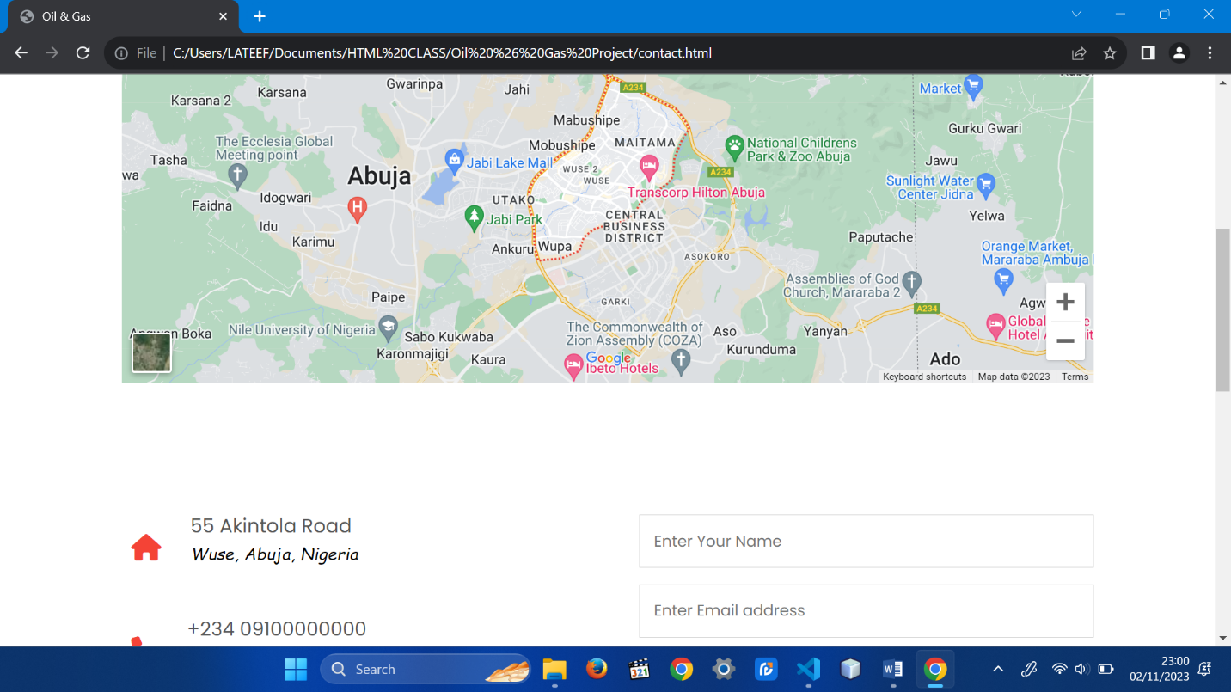

*Fig 3.1 The Contact page*

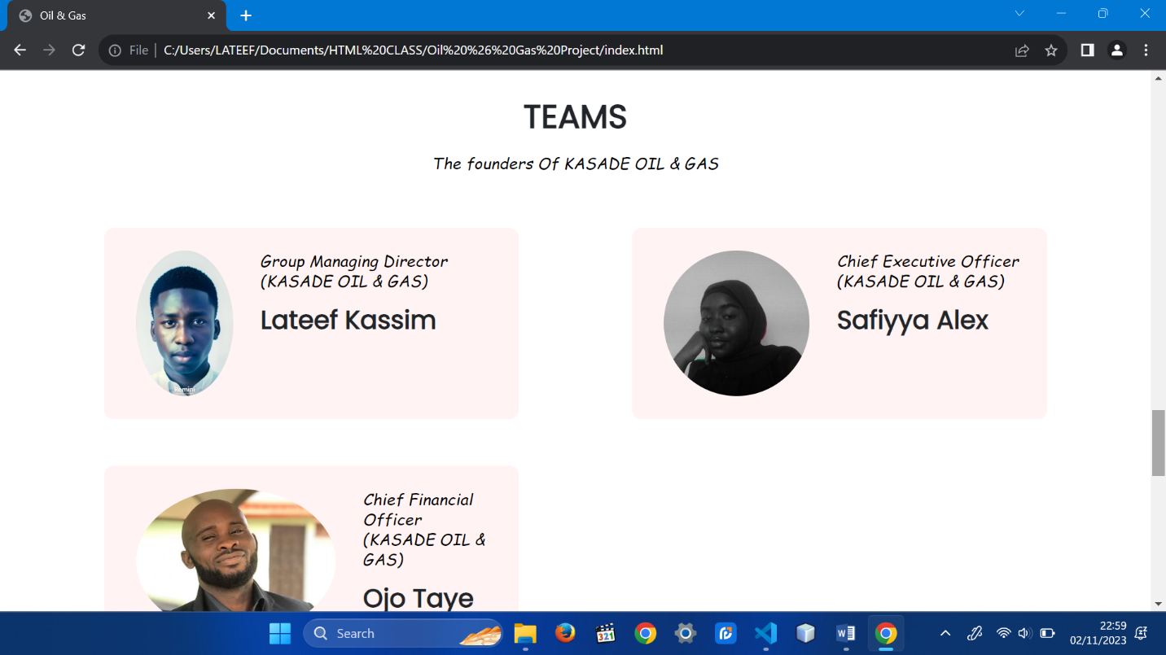

*Fig 3.2 Teams*

*Fig 3.3 Block of codes written for the website.*

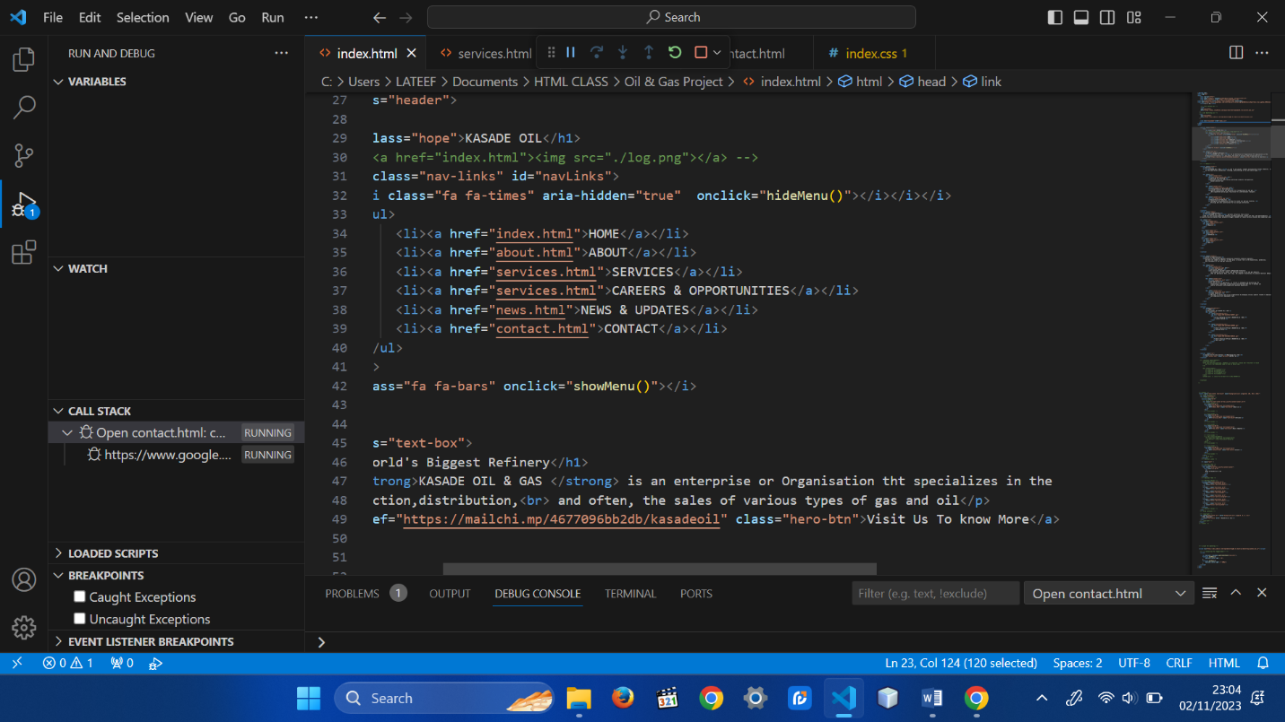

*Fig 3.4 Service Page*

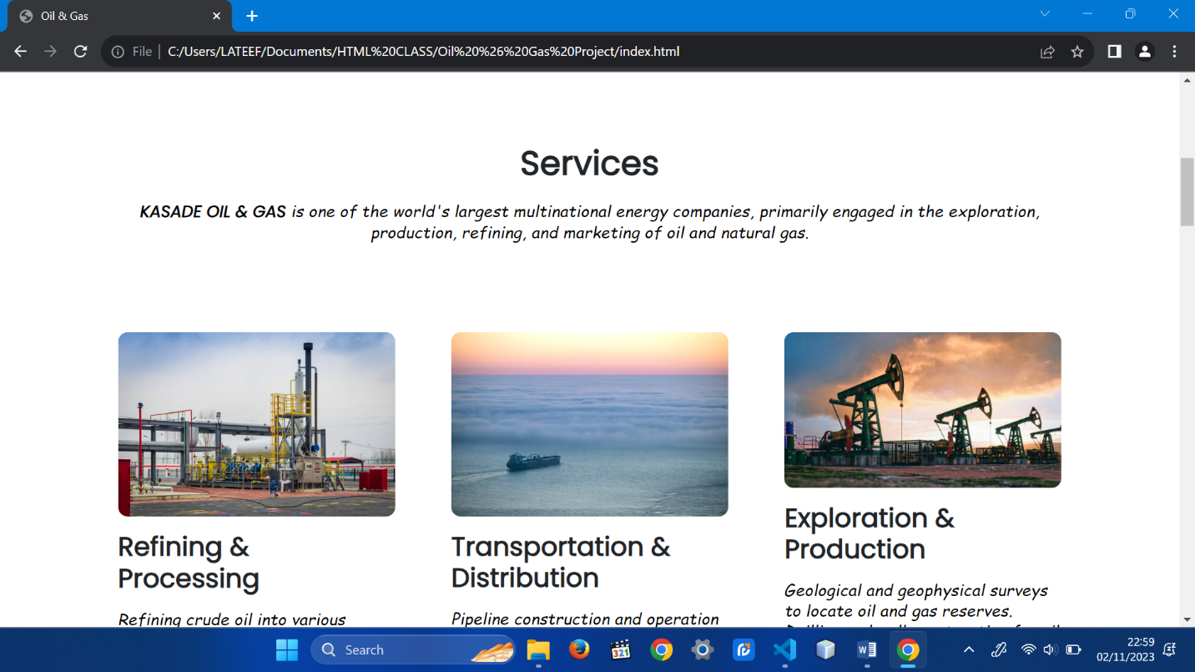

# **CHAPTER FOUR**

## SUMMARY, CONCLUSION AND RECOMMENDATION

### 4.1 SUMMARY

The oil and gas website is a comprehensive online platform dedicated to the energy industry. It offers a wealth of information on various aspects of the sector, including exploration, production, environmental sustainability, and industry trends. Visitors can access detailed articles, reports, and resources to stay informed about the latest developments in the field.

### 4.2 CONCLUSION

"In conclusion, our oil and gas website serves as a valuable resource for all those interested in the energy industry. We have provided comprehensive information on various aspects of the sector, from exploration and production to environmental sustainability. Our commitment to safety, innovation, and responsible energy practices is evident throughout the content.

We invite you to explore the wealth of resources available on our site, whether you are an industry professional, an investor, or someone interested in learning more about the role of oil and gas in our world. As we navigate the ever-evolving energy landscape, we remain dedicated to advancing technology, minimizing environmental impact, and contributing to a more sustainable future.

Stay connected with us for the latest updates, news, and insights in the oil and gas industry. If you have any questions or would like to engage in a partnership or investment opportunity, please don't hesitate to contact us. We appreciate your interest and look forward to a brighter and cleaner energy future together."

# **REFRENCES**

# References

We all need a website, to stand out when you're looking for a job, to let people know that you're opening a business, to bring in more customers to your current business. In this video I'm going to show you FOUR options to create a website for FREE and the benefits and disadvantages of not paying for a custom domain name.

https://youtu.be/kdOCHkgeLNc?si=pShSnumRRLL27iWX